Nicholas Primiano

Section 001

17 October 2016

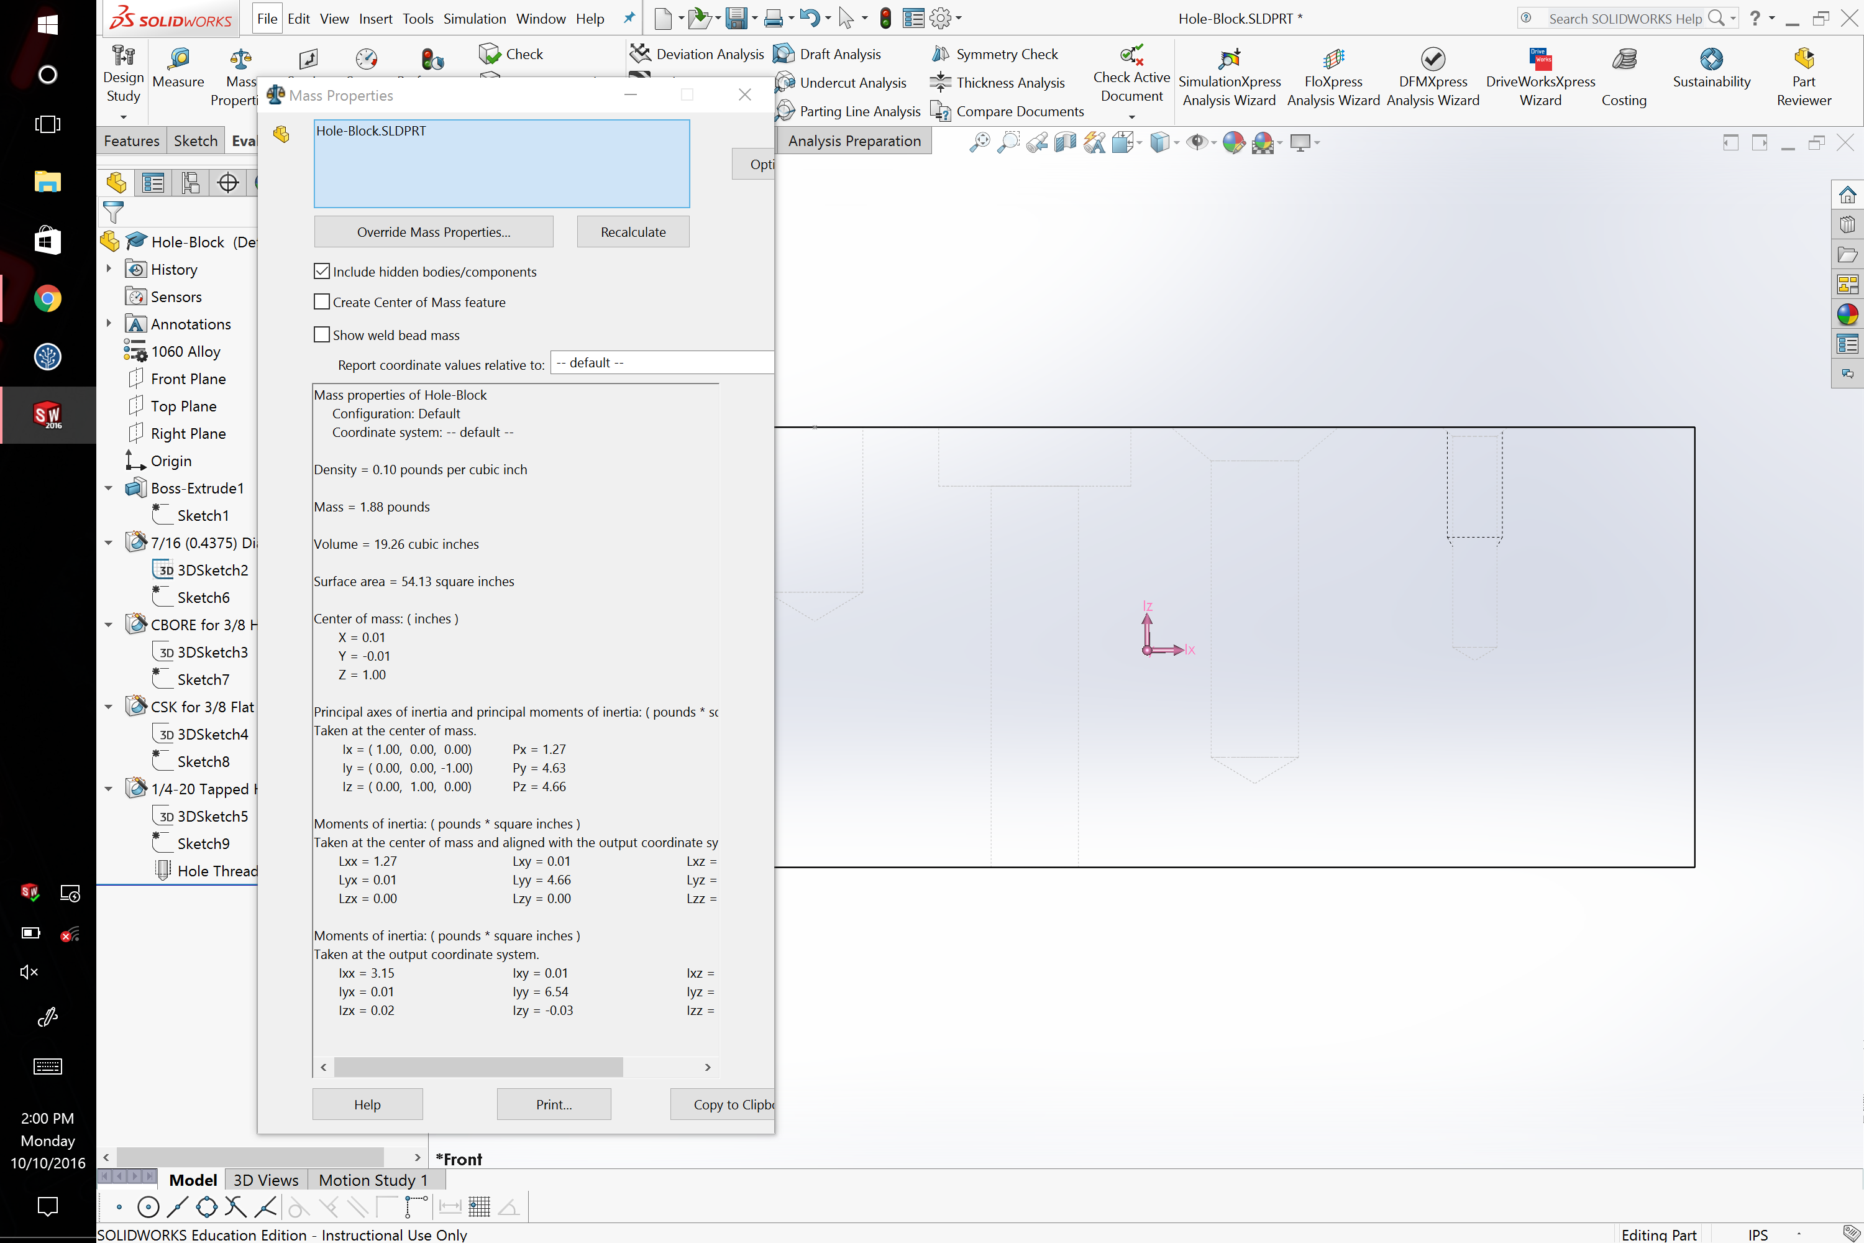

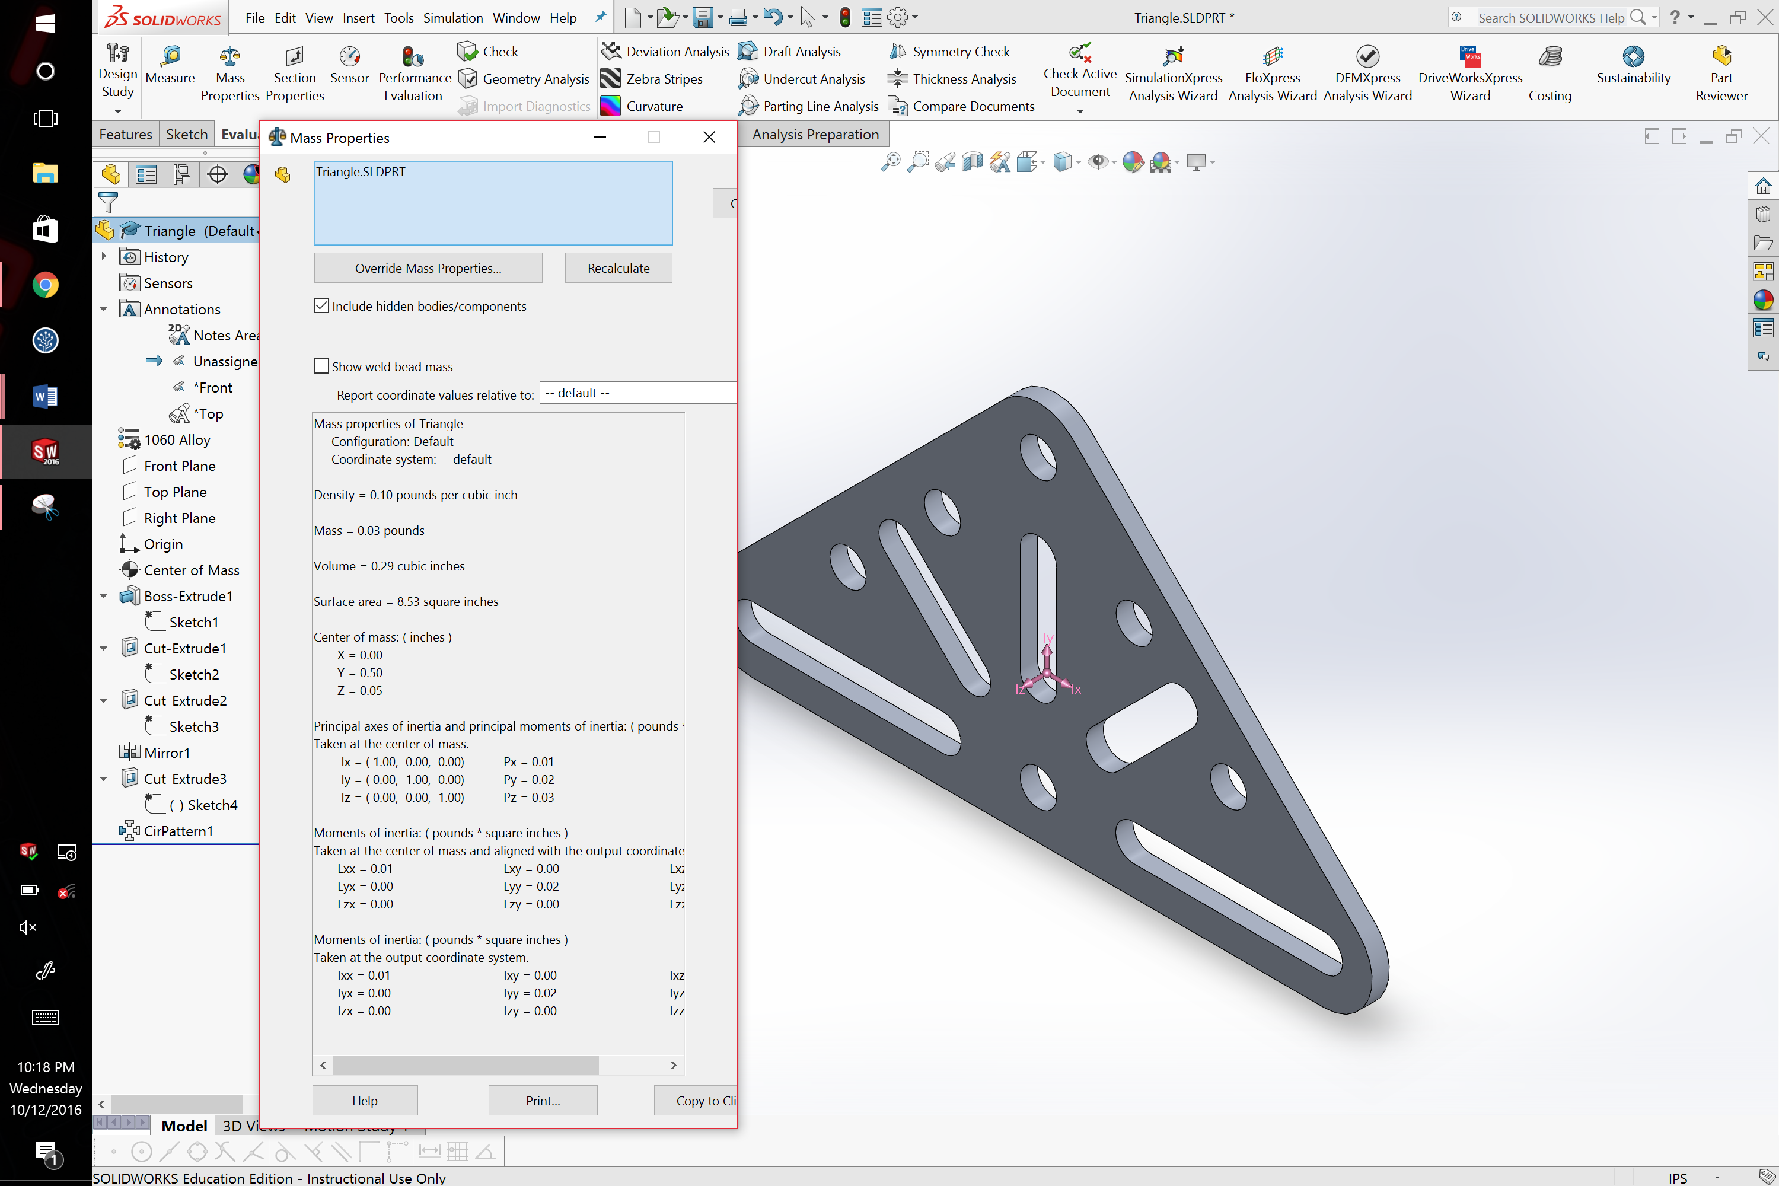

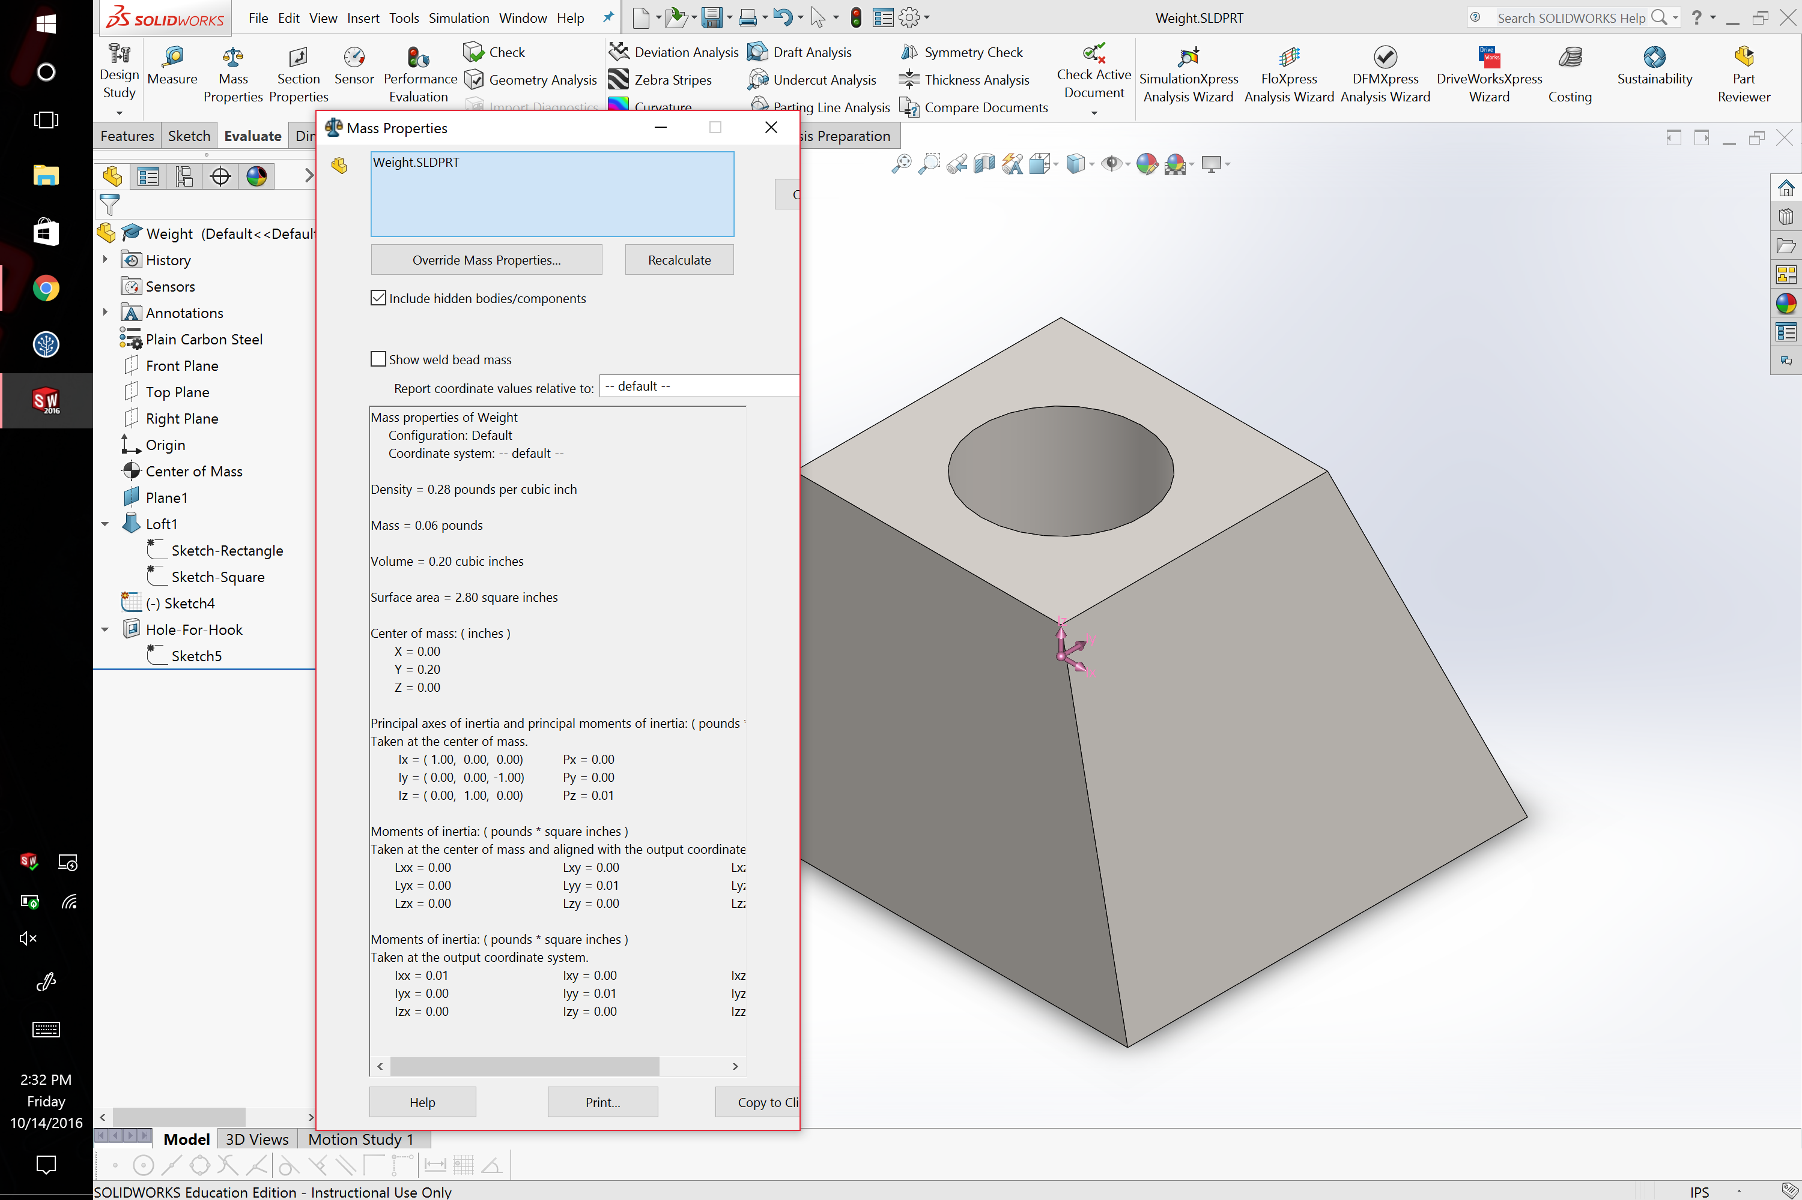

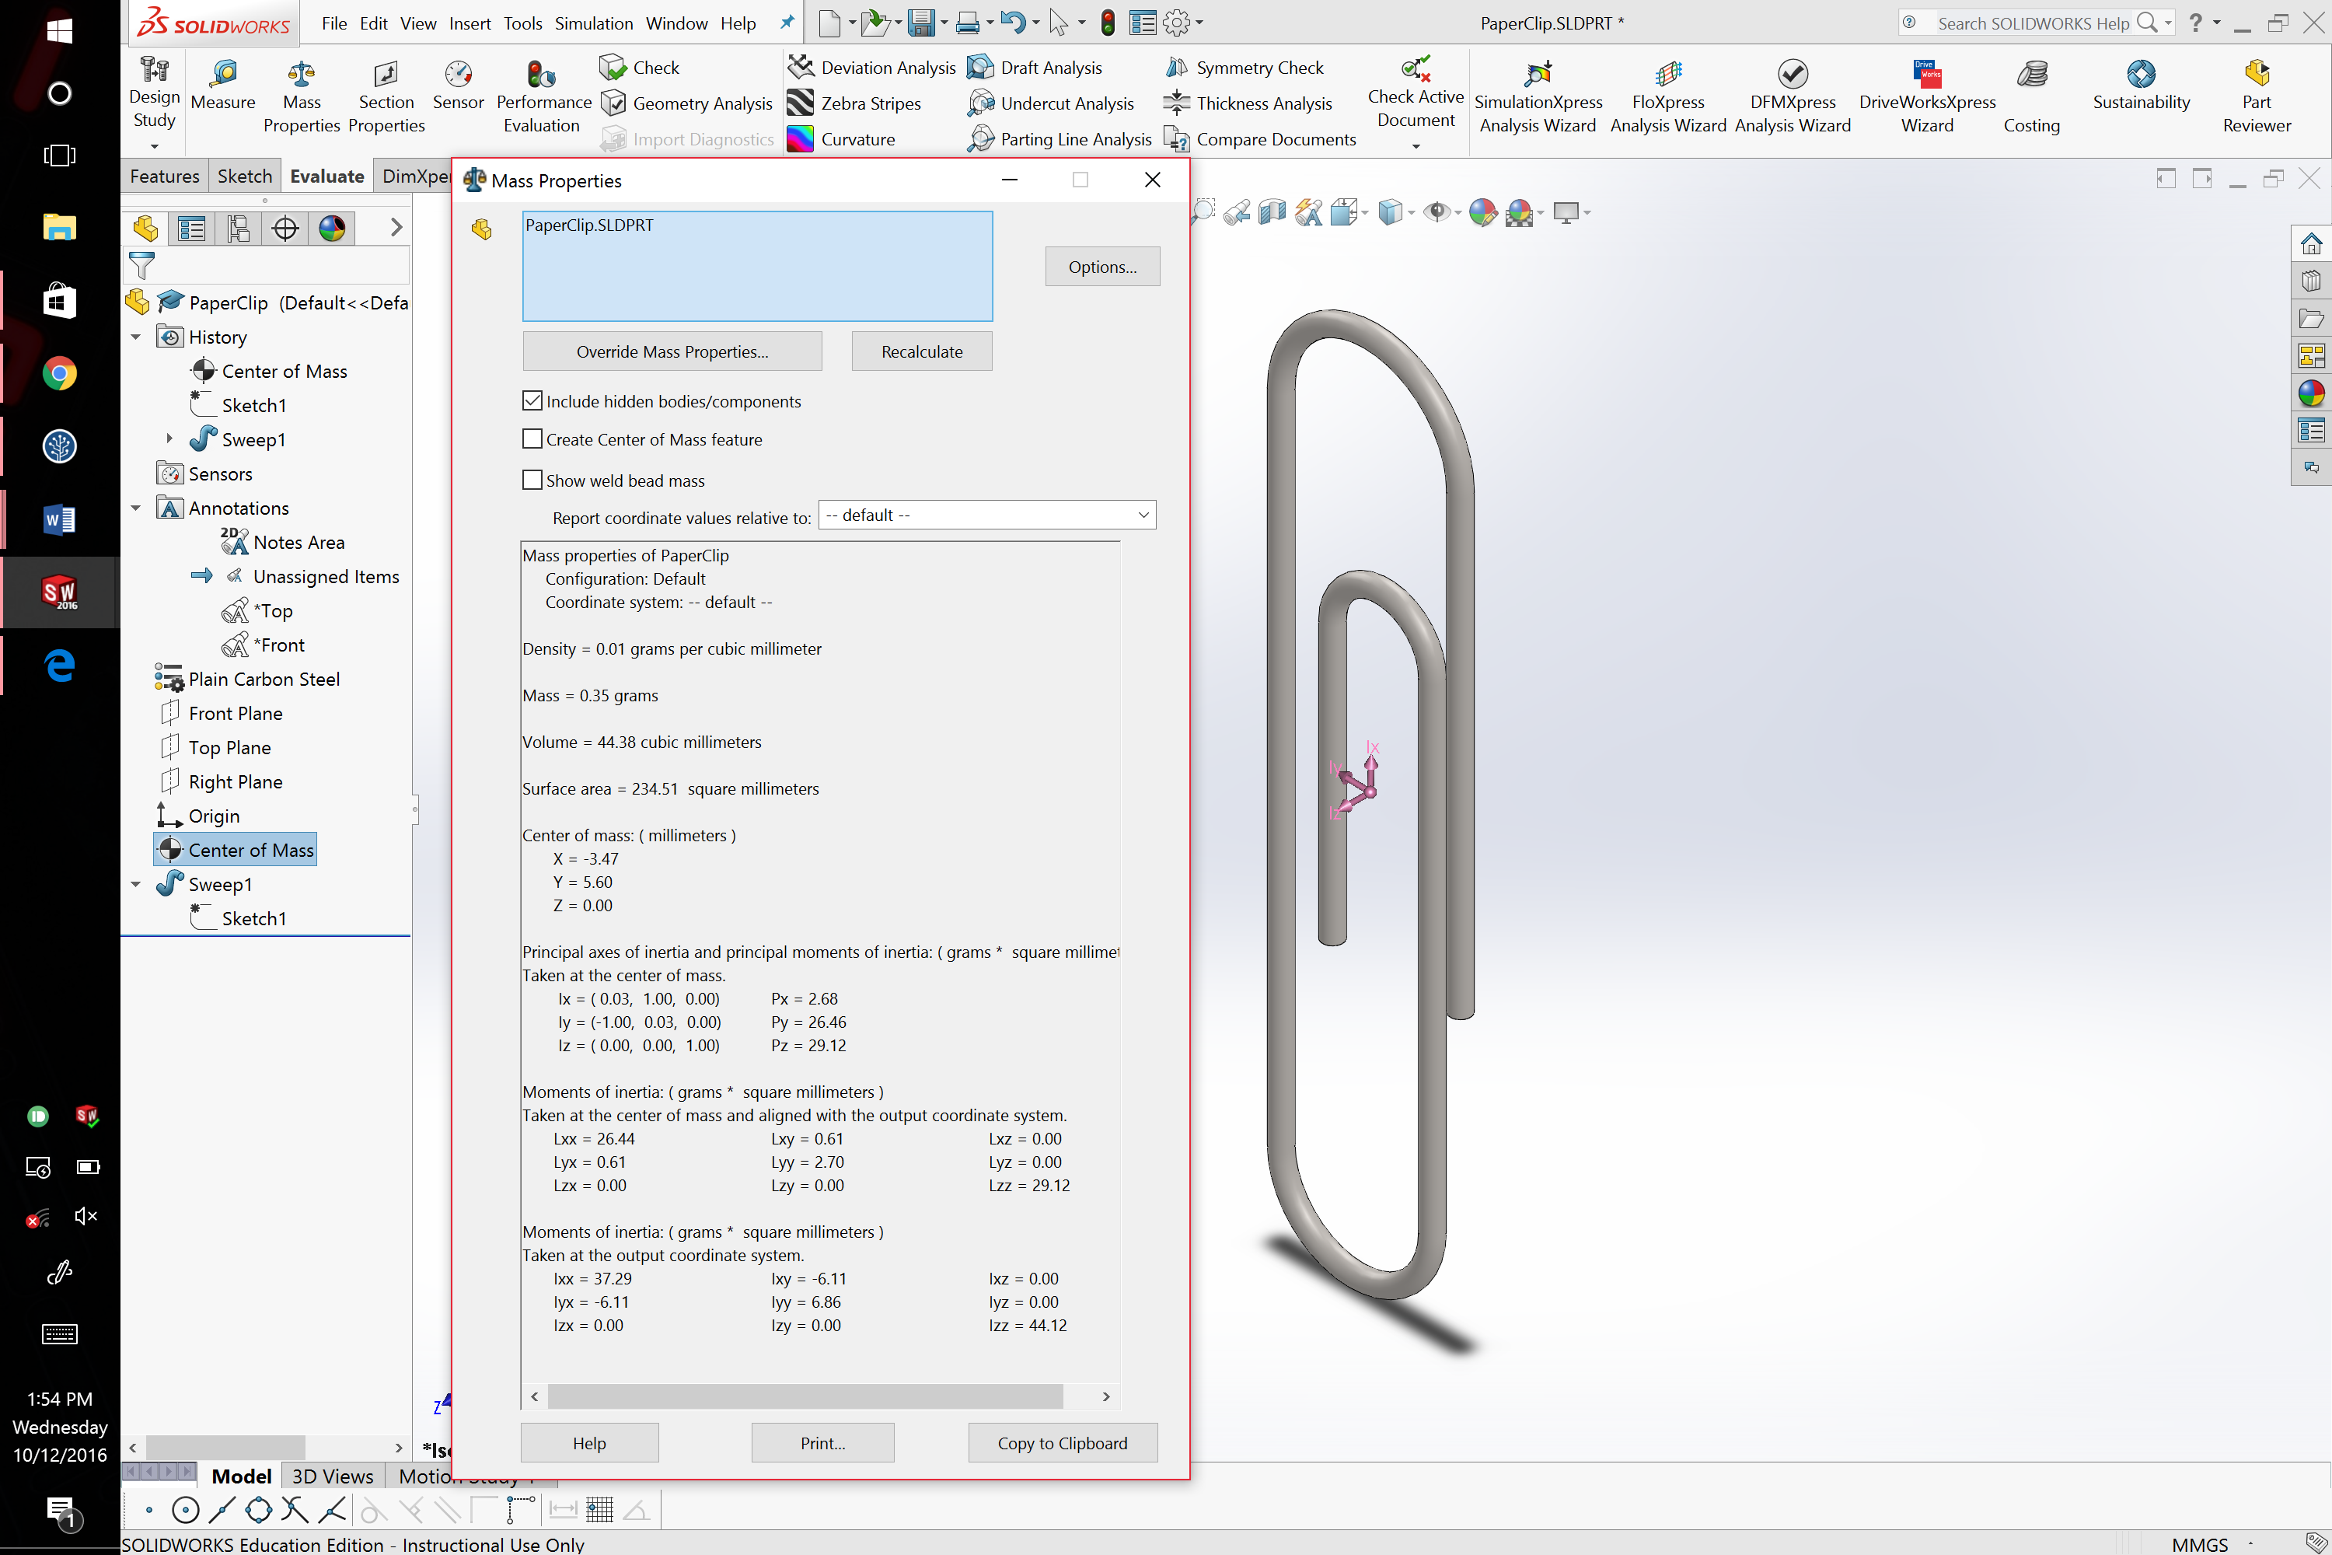

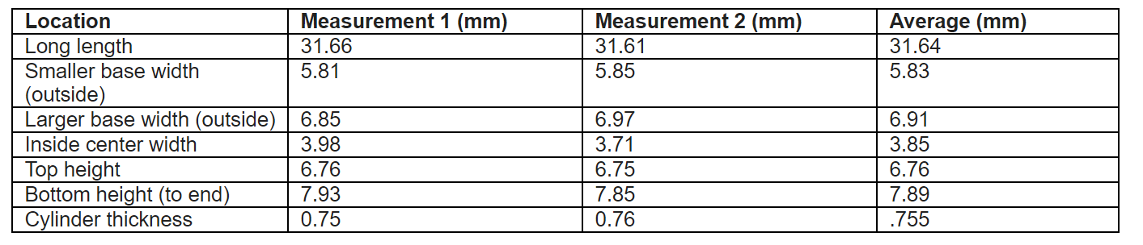

1. A precision of two decimal places was chosen. This was dictated by the precision of the measuring tool (caliper). Additionally, more precision would not be necessary to manufacture a paperclip.

